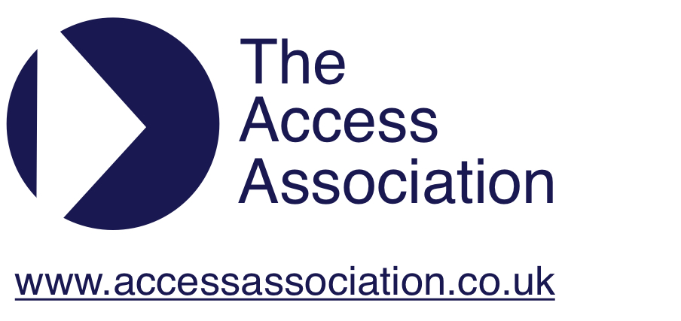
LONDON with SOUTH EAST
REGION
CHAIRMAN:
Pip Jackson
Building Control Service Manager
Supporting Communities
LB of Camden, 5 Pancras Square
London, N1C 4AG
Tel: 020 7974 2305
Mobile: 07771 334 369
Email: Philippa.jackson@camden.gov.uk

Presentation: Being an Expert Witness in Court on an Equality Act Judgement by Liam Proudlock.

Minutes of the Meeting Held on Wednesday, 27th November, 2018
(Venue: Guildhall North Wing – Meeting Room 2).

In attendance:

Phillippa Jackson, Shannon Keys, Olufunmi Adeoye, Julie Fleck, Ronald Koorm, Jan Loveless, Rachael Marshall, Peter Monk, Lydia Morley, Fara Muneer, Liam Proudlock, Tracey Proudlock, David Spooner, Jennifer Wheeler.

Apologies

Apologies were received from: Salli Booth, Lady-Marie Dawson-Malcolm, Jon Dyster, Clive Durdle, Barry Ginley, Chris Harrowell, Jean Hewitt, Michelle Horn, Sarah Lindeman, Kate McGechan, John Osborne, Elisenda Rifé, Jacquel Runnalls, Rachel Smalley, Jacqui Smith, Natalie South, and Judi Watkinson.

- Minutes of the July meeting.

Accepted.

- Matters arising not covered on the Agenda.

None.

- Treasurer’s Report.

Account status:
Community account: | £115.20
Business savings: | £498.30
Total held in accounts | £613.50
Recent income: | £0.00
Recent expenditure: | £34.80 |  | Refreshments Guildhall
Interest | £0.08

The region applied to Paul, the National Treasurer, for this year's Regional Allowance, but as we currently have funds in our reserves, he is advising that we do not apply yet unless we have specific justification for the requirement. We are therefore proposing to use up more of our reserves over the coming year before re-applying for the Regional Allowance.

To make payments for items such as Guildhall refreshments and the Christmas Lunch easier, we have applied for an HSBC Bank card, as currently we can only pay for items by cheque or online transfer. HSBC have confirmed there are no charges provided the account remains in credit.

- Current Consultation Documents needing response and recent publications of interest.

- Planning reform: supporting the high street and increasing the delivery of new homes. https://www.gov.uk/government/consultations/planning-reform-supporting-the-high-street-and-increasing-the-delivery-of-new-homes closes 14th January, 2019. Consultation on a package of measures to provide greater planning certainty to support the high street and ensure that we can deliver new homes in the right places, and without delay.

- The City of London Corporation’s public consultation on the draft new City of London Local Plan called City Plan 2036, closes 28th February, 2019. Details and draft plan available at: https://www.cityoflondon.gov.uk/services/environment-and-planning/planning/planning-policy/Pages/Local-Plan-Review.aspx.

- The Home Builders Federation (HBF) has been in the media recently—including in the Private Eye current affairs magazine—for submissions made to at least 17 local authorities objecting to planning policies requiring accessible homes. Peter Monk forwarded a scanned version of the Private Eye article. Another can be read at: https://www.theguardian.com/society/2018/nov/28/builders-criticised-for-lobbying-against-accessible-homes?CMP=share_btn_link.

- National Council News.

Pip attended the November National Council meeting as National Secretary.

National Council is not releasing funds to regions that are currently holding reserves, which many are. Doing so, may assist the National Council with its plans to make website improvements.

The Treasurer will put together a paper on what to do if regions want to run a big event and want resources / funds to assist with this.

The Council is considering running two half-day events per year, with the AGM held at one of the events, instead of the current full-day AGM and CPD. The (full-day) AGM is a lot of work, involves offering lunch, requires sponsors to help offset costs, etc. Some regions are also struggling and have very few members and, as a result, do not meet often. Providing two CPD events per year, could offer more opportunities and more value for membership fees to those in smaller regions. The council is exploring the requirements for holding an AGM (e.g. how much ‘business’ has to be done at the AGM vs how much can be done by circulating information in advance) before a decision is reached.

The next National Council meeting will be in February – location TBC.

- Future CPD programme.

Tracey apologised for not having circulated a list of possible CPD ideas for people to select their top three choices to be pursued. She asked for clarification regarding the laser technology item from the last minutes. A visit to Microsoft has proven difficult to arrange, however it still remains a possibility.

The (9th) January meeting is a networking and social meeting. Several ideas for locations were raised. The venue must:
- centrally located;
- have wheelchair-accessible parking;
- have a working wheelchair-accessible WC;
- be relatively quiet to allow conversation;
- accommodate a variety of dietary restrictions / requirements (e.g. vegan, GF, etc.);
- be reasonably priced.

Julie Fleck agreed to check out the Wellcome Collection’s restaurant and access provisions (including size and load of platform lift) to determine if it might be an option. LP offered to take over after Julie’s visit.
Post-meeting note: Jan Loveless subsequently offered to organise. An email was circulated on the 5th December, 2018 asking for everyone planning to attend to email Jan by 13th December, 2018 to confirm attendance, menu selection, and advise of any specific dietary or access requirements.

- AOB.

- Tracey Proudlock was on TV for Purple Tuesday. Tracey said that everyone should aim higher so that disable people can shop everyday, not only on select days. What’s more sinister reports—not verified—that DWP was given videos of people shopping on the day, which could be used against them for their PIP claims.

- Jenny Wheeler questioned whether anyone had contacts or experience with O2 as on a recent visit, she found that their Changing Places Facility was ‘shocking’ – e.g. the hoist was holding the changing bench up and when the hoist was moved, the bench fall. JW to email Pip details; Pip said the O2 has an access group. JW complained, but while they were being ushered out of the venue.

Date of next meeting: Wednesday, 9th January, 2018. Location: Wellcome Kitchen on the 2nd floor of the Wellcome Centre, 183 Euston Road, London, NW1 2BE. (See item 6 above).

